Validating tokens and certificate

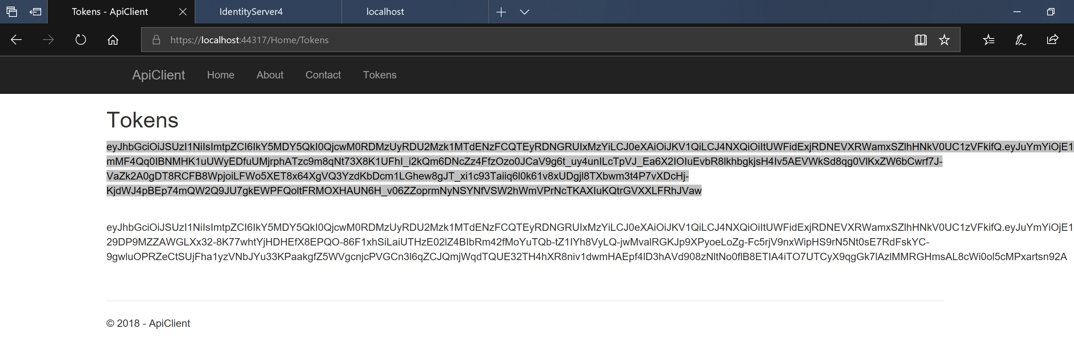

From the tokens view we built copy one of the tokens and go to <https://jwt.io/>

Paste the token to see something like this, with all three parts of the token parsed

Including the custom claims etc

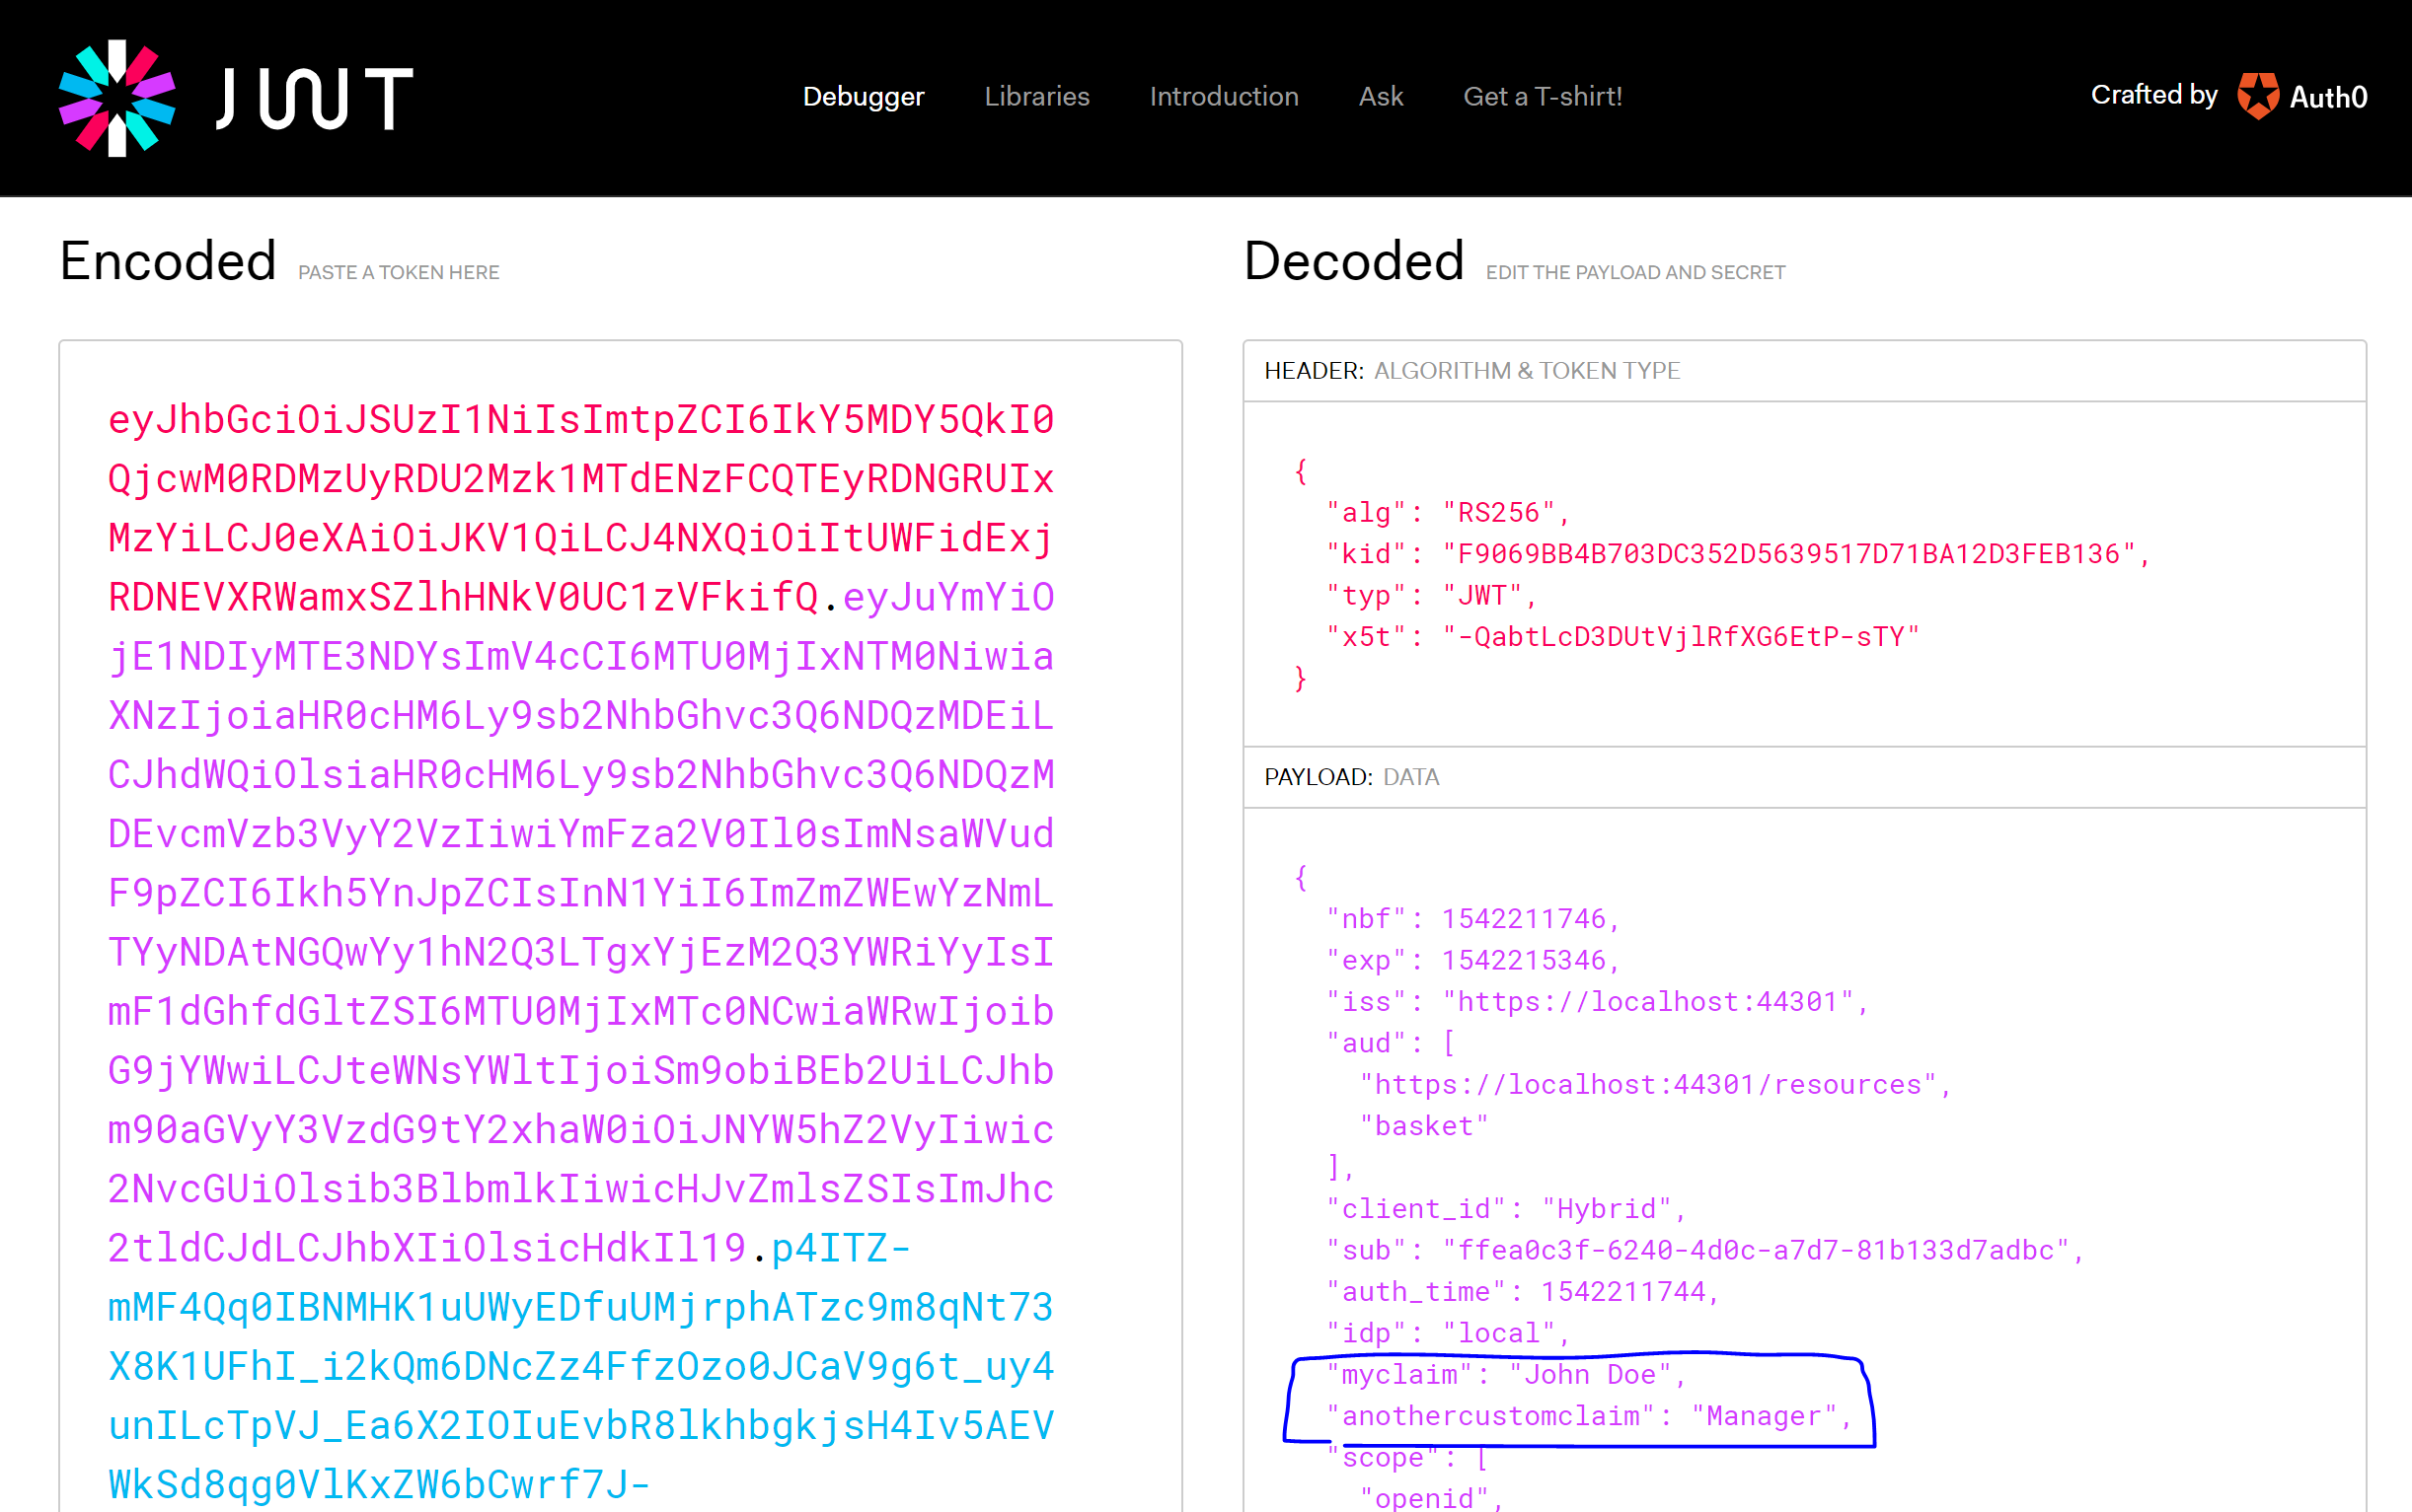

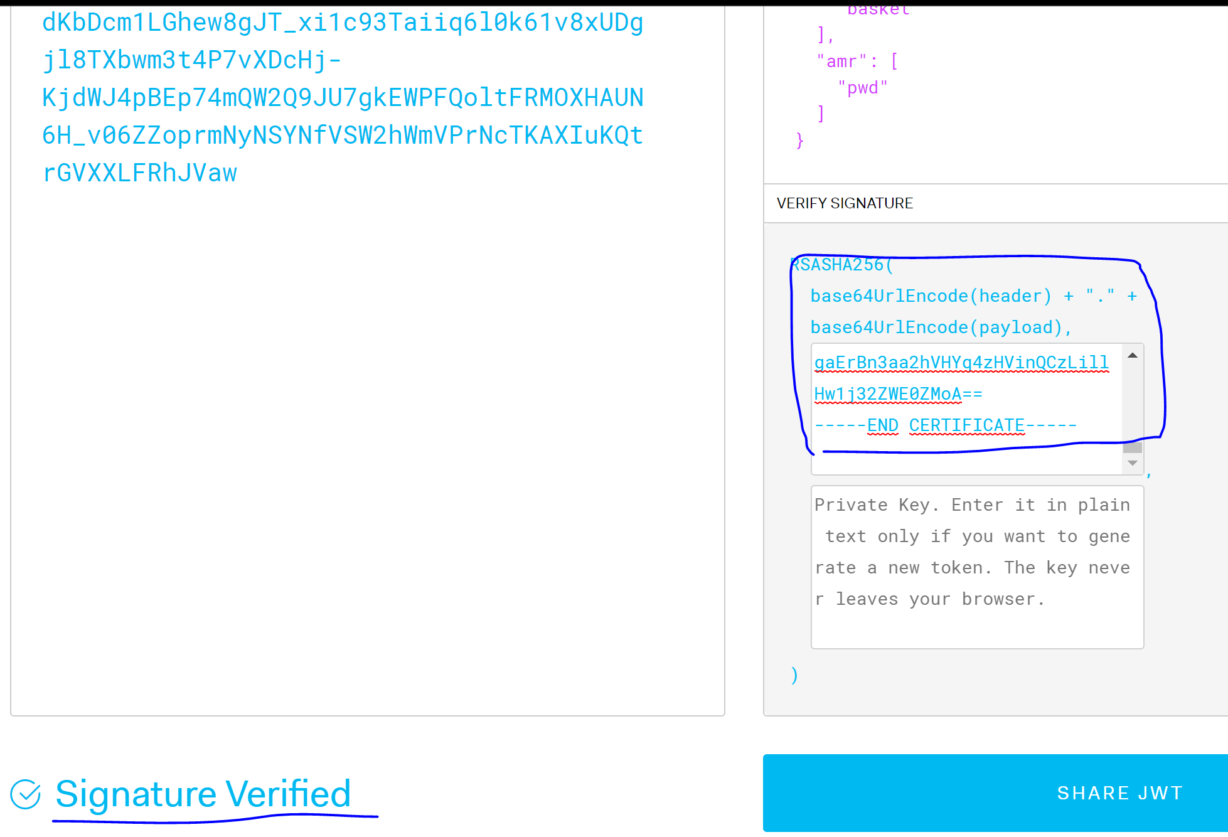

To verify the signature you need the base 64 export of the certificate

Go to mmc to see certificates of the local computer account

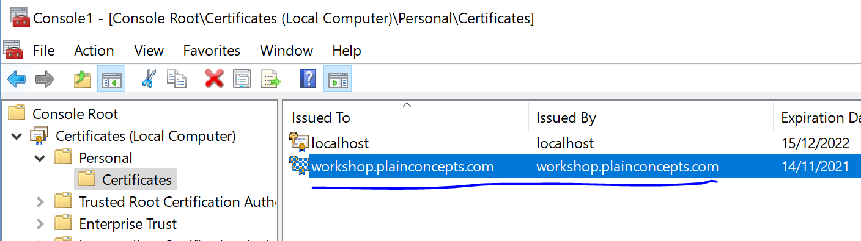

Export to base64 .cer file like this

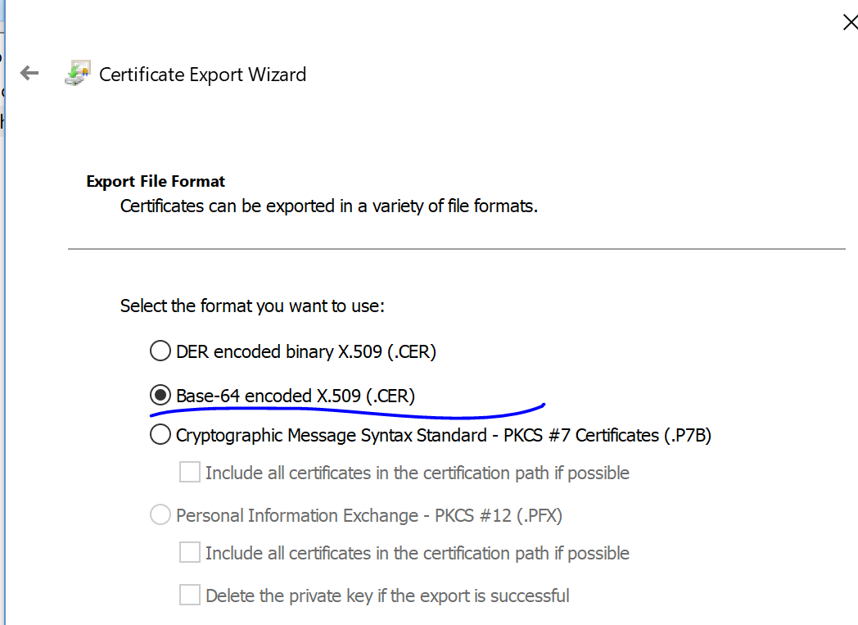

Then just open it on notepad to see sometjing like this

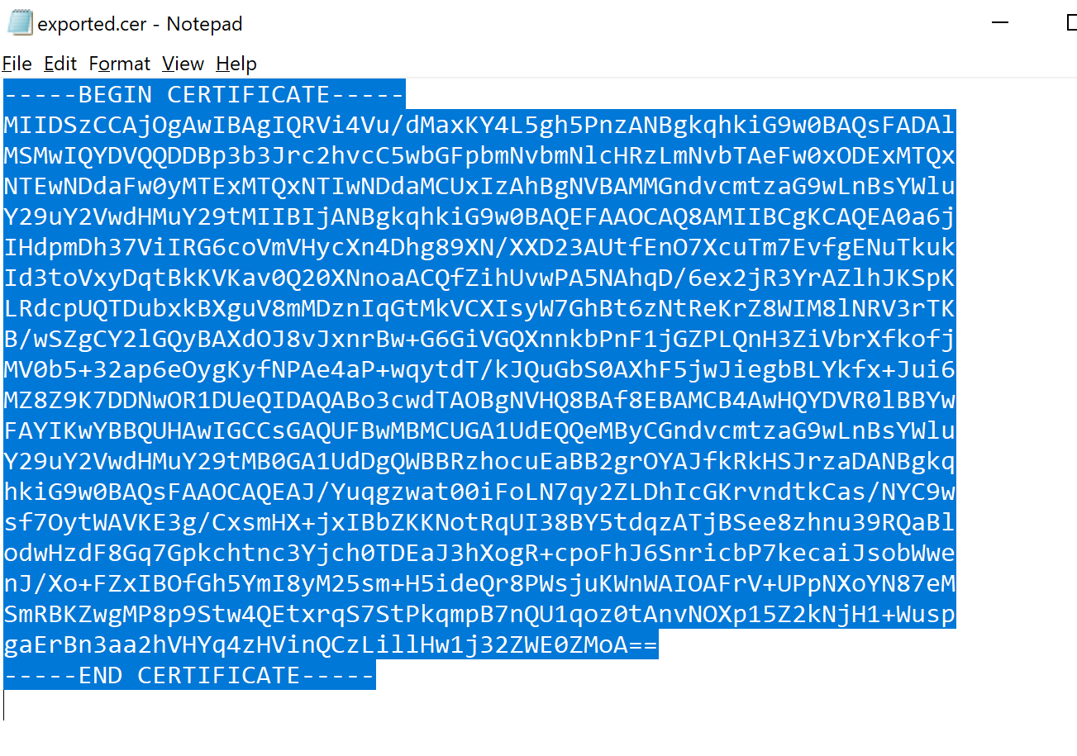

Copy all of the content to paste it on the jwt.io page to verify the signature

